**TY CSE AY-2022-23 Sem-I**

**Artificial Intelligence and Machine Learning Lab**

**Assignment No 1 Due date- 26/08/2022**

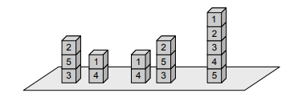

Formulate the above version of the block’s world as a search problem, by precisely defining the state space, the initial state, the goal test, the set of possible actions and the path cost (based on cost of moving blocks).

1. You start with the sequence ABABAECCEC, or in general any sequence made from A, B, C, and E. You can transform this sequence using the following equalities: AC = E, AB = BC, BB = E, and E * x = x for any x. For example, ABBC can be transformed into AEC, and then AC, and then E. Your goal is to produce the sequence E.
2. For the tree given below

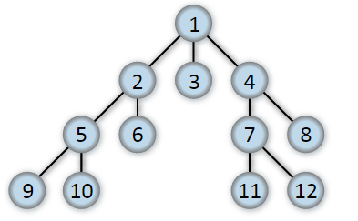

If starting state is 1 and goal state is 7, implement BFS and DFS search strategies for above tree. Which searching strategy will be best for this problem? Justify your answer with proper explanation.

1. Consider the traffic map of certain city is given below

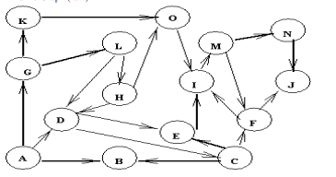

Identify different paths using

1. BFS with start state A and goal state N
2. DFS with start state A and goal state N
3. For the graph given below

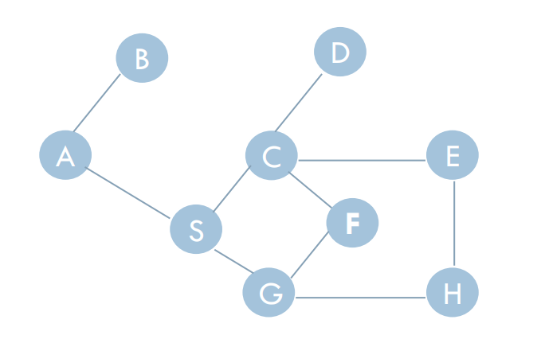

Implement BFS and DFS technique to identify a path from start node A to goal node E.

***********************************